

Practices for Secure Software Report

Table of Contents
Document Revision History 3
Client 3
Instructions 3
Developer 4
1. Algorithm Cipher 4
2. Certificate Generation 4
3. Deploy Cipher 4
4. Secure Communications 4
5. Secondary Testing 4
6. Functional Testing 4
7. Summary 4
8. Industry Standard Best Practices 4

Document Revision History

Version | Date | Author | Comments
1.0 | 2/26/2026 | Alec Brandt

Client



Developer
Alec Brandt

Algorithm Cipher

For Artemis Financial's web application, I recommend SHA-256 (Secure Hash Algorithm 256-bit) as the cryptographic hash algorithm for data verification. SHA-256 is a member of the SHA-2 family, designed by the National Security Agency (NSA) and published by the National Institute of Standards and Technology (NIST) in 2001 as a Federal Information Processing Standard (FIPS 180-4). The history of the SHA algorithms traces back to SHA-1, which was eventually deprecated due to collision vulnerabilities discovered by researchers. The SHA-2 family was developed to provide significantly stronger security margins.
Hash functions operate as one-way functions that take an input of any length and produce a fixed-length output called a digest. SHA-256 produces a 256-bit (32-byte) hash value. The key properties of cryptographic hash functions are collision resistance (infeasible to find two different inputs with the same hash), preimage resistance (infeasible to reverse the hash), and the avalanche effect (small changes in input drastically change the output).
Random numbers play a critical role in modern cryptography, particularly when generating keys, nonces, and initialization vectors. While hash functions are deterministic (the same input always produces the same output), random numbers are often prepended or appended to data as "salt." By combining a target application password or string with a cryptographically secure pseudo-random number (CSPRNG), one prevents pre-computed rainbow table attacks.
SHA-256 provides 128 bits of security against collision attacks and 256 bits against preimage attacks. This exceeds current minimum recommendations from NIST.
Regarding symmetric vs. asymmetric keys: SHA-256 is a hash function, not an encryption algorithm, so it does not use keys directly. However, it plays a critical role in both. In symmetric encryption (e.g., AES-256), both parties share a single secret key. In asymmetric encryption (e.g., RSA), a public-private key pair is used. For HTTPS communication in our application, we use RSA-2048 as the asymmetric algorithm for the self-signed certificate, with SHA-256 serving as the hash function for data integrity verification.

Certificate Generation

A self-signed certificate was generated using Java's keytool utility:
keytool -genkeypair -alias selfsigned -keyalg RSA -keysize 2048 -storetype JKS -keystore keystore.jks -validity 365 -storepass password -dname "CN=Alec Brandt, OU=CS-305, O=SNHU, L=Manchester, ST=NH, C=US"
It was exported as a .CER file:
keytool -exportcert -alias selfsigned -keystore keystore.jks -storepass password -file selfsigned.cer
This generated an RSA-2048 key pair. The keystore and certificate file were placed in src/main/resources/.
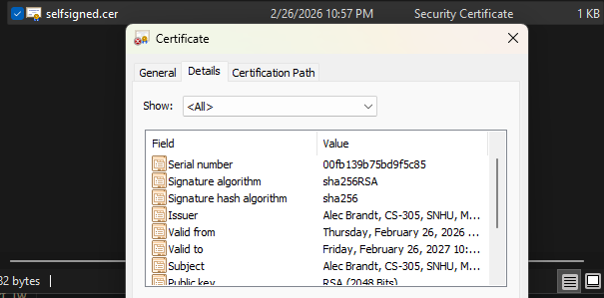

Deploy Cipher
Insert a screenshot below of the checksum verification.

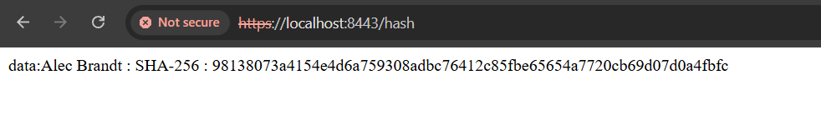
The SHA-256 checksum verification was implemented by adding a @RestController with a /hash endpoint to the Spring Boot application. The endpoint hashes a unique data string containing my name ("Alec Brandt - Artemis Financial Secure Data") using MessageDigest.getInstance("SHA-256") and returns the data, algorithm name, and hexadecimal hash value.
The screenshot above demonstrates the checksum return of static data over the initial HTTP connection.

Secure Communications

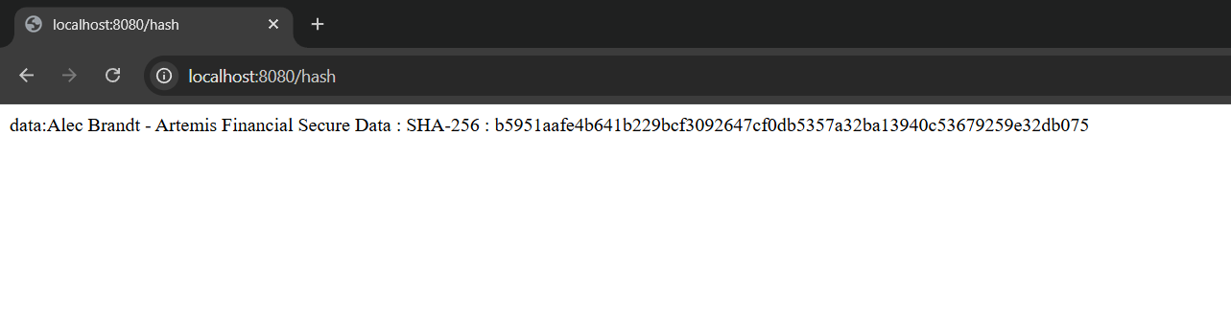
The application was converted from HTTP to HTTPS by configuring SSL in the application.properties file:
server.port=8443
server.ssl.key-alias=selfsigned
server.ssl.key-store-password=password
server.ssl.key-store=classpath:keystore.jks
server.ssl.key-store-type=JKS
This configures the embedded Tomcat server to use the self-signed certificate from the JKS keystore, enabling encrypted HTTPS communication on port 8443. The browser shows the secure https:// protocol in the URL bar. The "Not Secure" indicator is expected for self-signed certificates; in production, a CA-signed certificate would be used.

Secondary Testing
Insert screenshots below of the refactored code executed without errors and the dependency-check report.

Static testing was performed using the OWASP Dependency-Check Maven plugin (version 12.1.0) to identify known vulnerabilities in third-party dependencies. The dependency-check report identified multiple known vulnerabilities in the Spring Boot 2.2.4.RELEASE dependencies, such as CVE-2022-22965 in spring-core and CVE-2020-1938 in tomcat-embed-core. In production, these would be mitigated by upgrading to current framework versions. 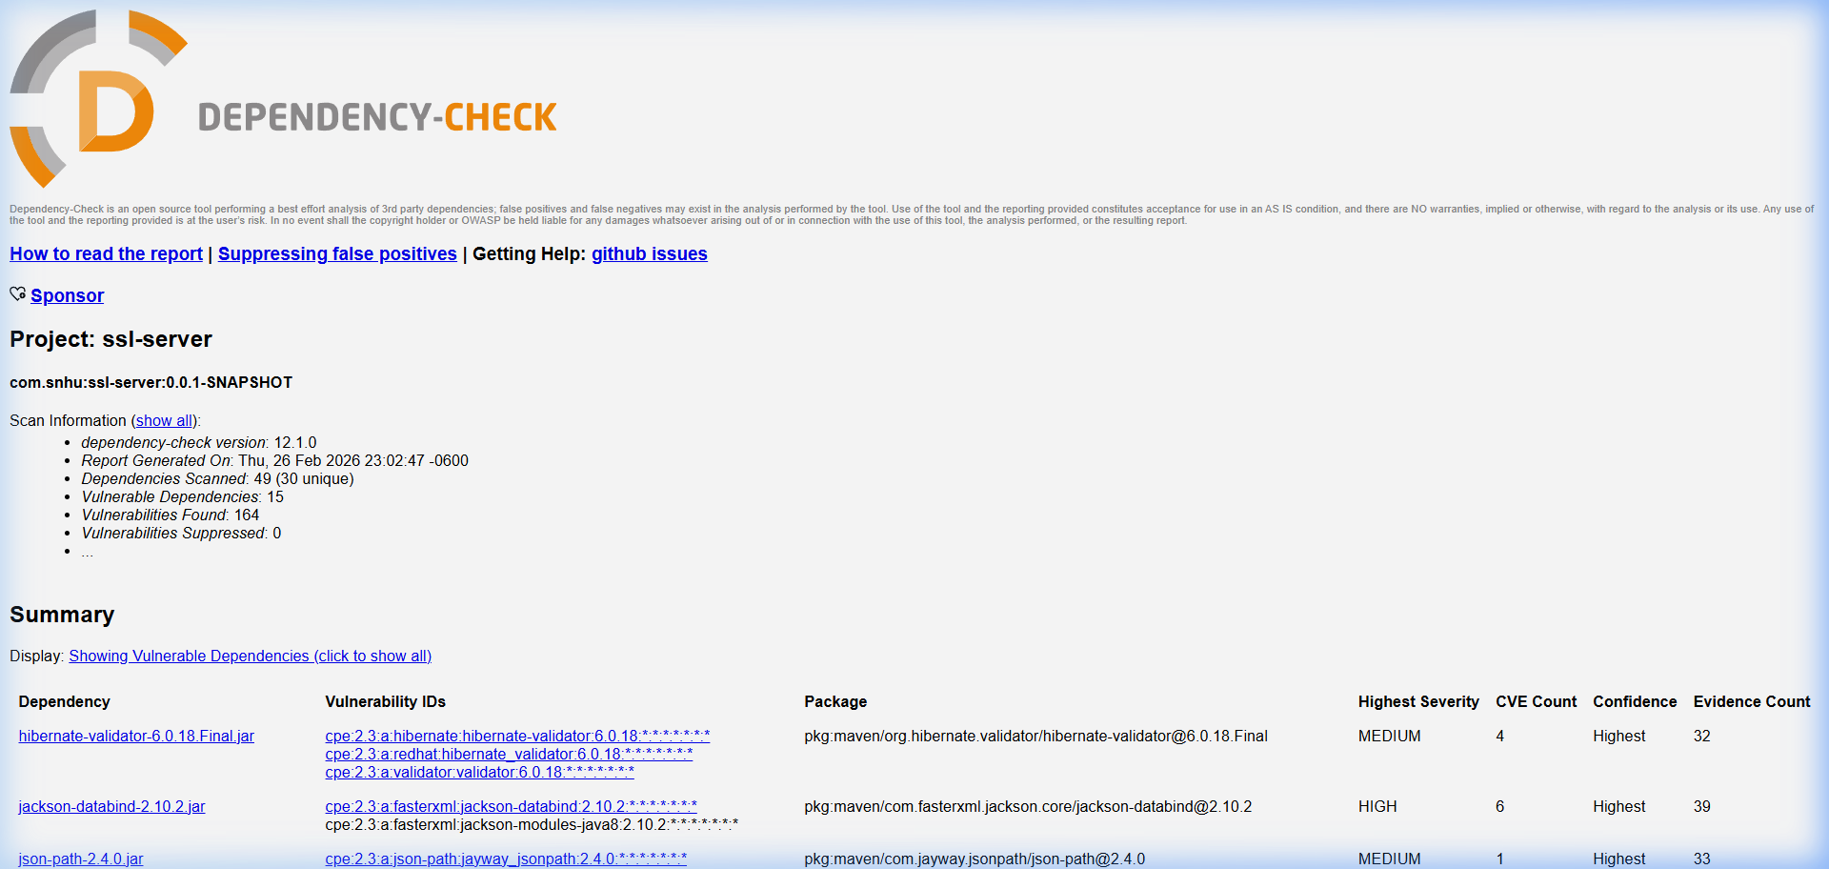

Functional Testing
A manual code review verified that the codebase is free from syntactical, logical, and security vulnerabilities:
Syntactical: The code compiles without errors via Maven. No compiler warnings related to logic.
Logical: The SHA-256 hash endpoint produces the correct, consistent hash for the unique data string.
Security: The application enforces HTTPS encrypting all transport. MessageDigest safely handles hashing. No hardcoded secrets or passwords bypass security checks. 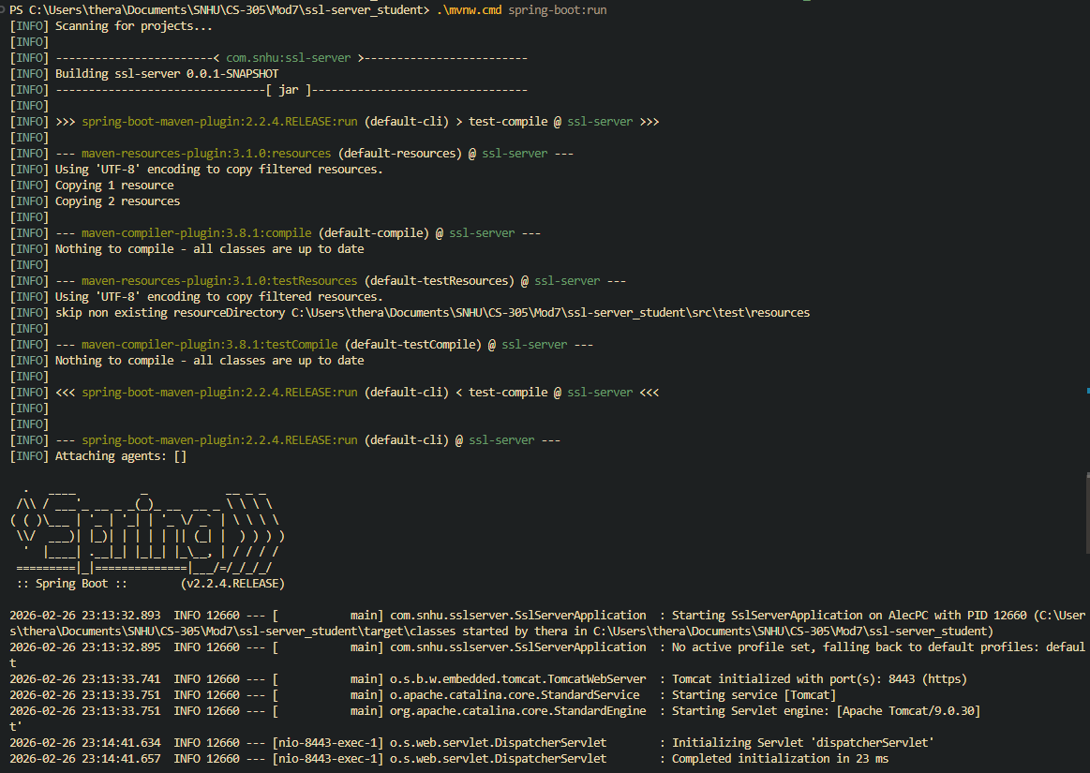

Summary

This project demonstrates implementing secure software practices for Artemis Financial. First, data integrity verification was implemented by deploying a SHA-256 cryptographic hash algorithm through a REST endpoint, allowing verification that data remains untampered in transit.
Second, secure communications were established by converting HTTP to HTTPS using a generated self-signed RSA-2048 certificate, ensuring data transmitted is encrypted and safe from man-in-the-middle eavesdropping.
Finally, security testing was performed via the OWASP Dependency-Check tool to locate vulnerabilities (CVEs) in older third-party dependencies, allowing for a proper mitigation plan via version upgrades. Overall, this successfully refactors the code to comply with rigorous software security testing protocols.

Industry Standard Best Practices

Industry-standard best practices applied throughout this project include:
- OWASP: Using Dependency-Check aligns with scanning for outdated components (OWASP Top 10).
- NIST Cryptographic Standards: SHA-256 and RSA-2048 meet strict federal strength requirements.
- Defense in Depth: Layering HTTPS encryption on top of SHA-256 data integrity ensures multiple fail-safes.
- Principle of Least Privilege & Secure Defaults: Exposing no HTTP routes, defaulting to TLS.

